Quantitative Analysis of Socio-Economic Factors on Income

Overview

This research project involves the utilization of a census-based dataset to investigate the statistical correlation between educational attainment and earning potential. The primary objective is the delivery of a data-driven visualization illustrating the influence of higher education degrees on financial mobility within the modern workforce.
Graphic Presentation
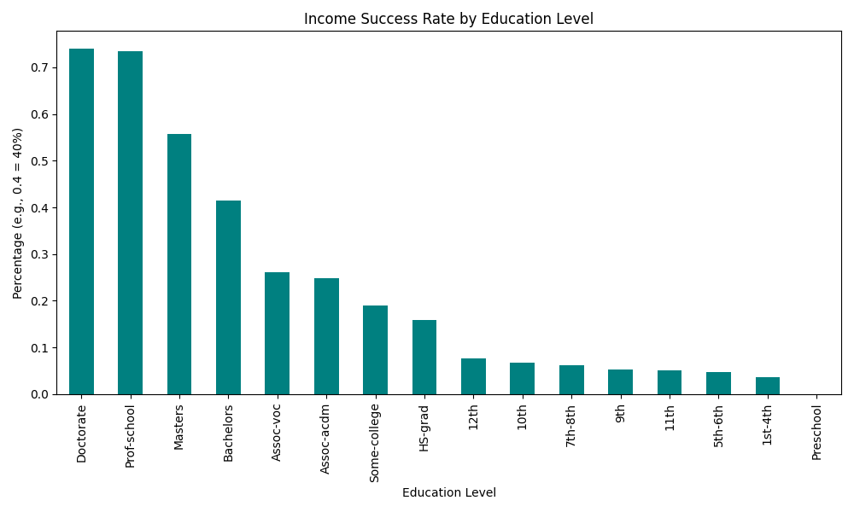

Technical Methodology
- Data Engineering: Development of a custom Python script to process over 32,000 demographic records, incorporating automated data cleaning to resolve categorical inconsistencies and whitespace errors.
- Library Implementation: Utilization of the Pandas library for large-scale data aggregation and the Matplotliblibrary for the generation of high-fidelity statistical visualizations.
- Logic & Analytics: Transformation of raw datasets into comparative trend analyses by calculating "Success Rates" (defined as the percentage of the population earning >$50k per year) across distinct educational tiers.
Key Insight
The analysis clearly demonstrates that individuals with a Doctorate or Professional School degree have a success rate of over 70%, compared to just 16% for those with only a high school diploma. This visual proof highlights the significant economic "ROI" (Return on Investment) of advanced education.

